Lab 02: Investigating a Compromised Machine
(Total points: 20)

Task 1:
- What is the version of the Operating System running on the Windows Machine? [Please provide a screenshot] (2 Points)
Answer:

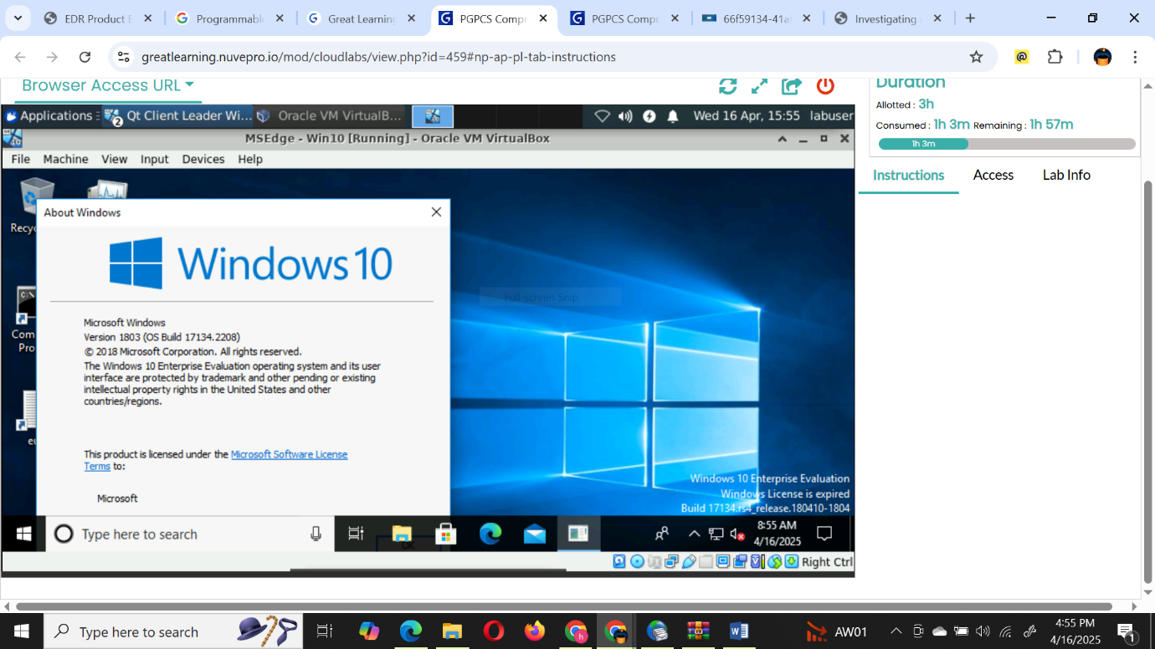

Operating System | Version
Microsoft Window | 1803 (OS Build 17134.2208)

Task 2:
- Which Port is used for SSH Communication? (2 Points)
Answer: 22

- What is the Process ID of the SSH communication on the compromised machine? (Please provide a screenshot of the command prompt output) (2 Points)
Answer: PID 2820
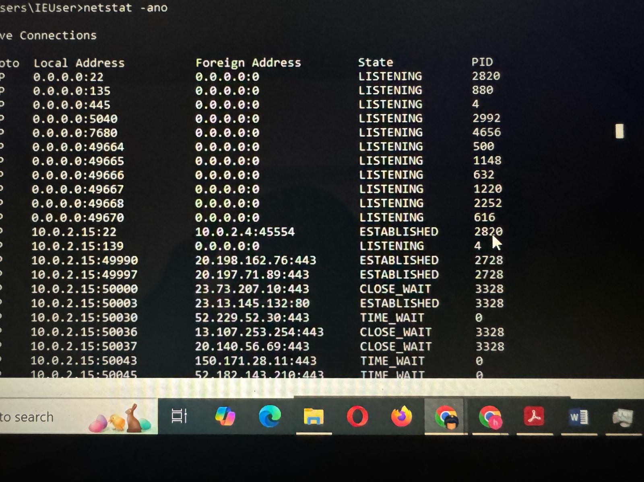

- What is the name of the file, which is making the SSH communication from the compromised machine? (Please provide a screenshot of the Task Manager) (2 Points)
Answer:
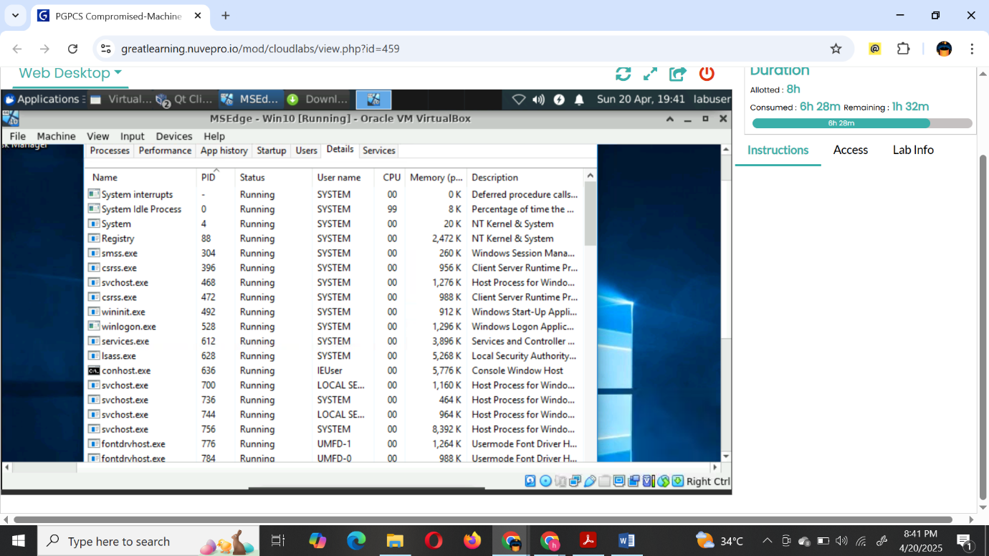

- Provide the screenshot of the hash values of this file. (2 Points)
Answer:

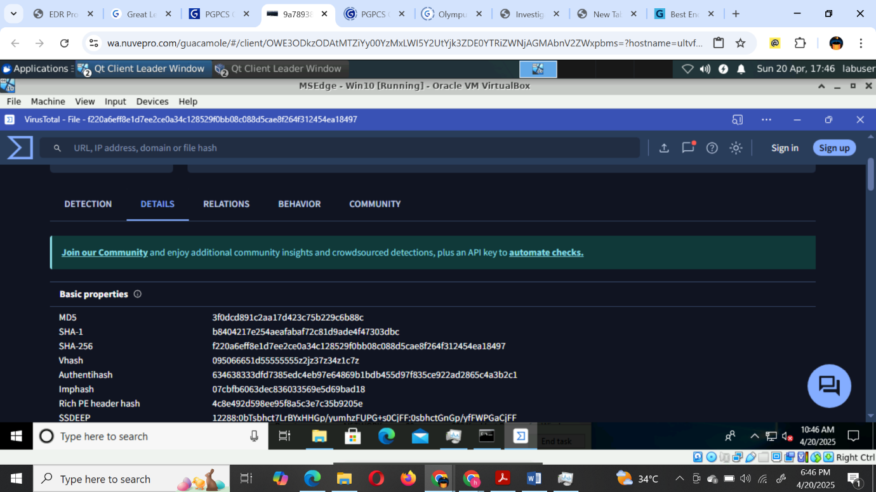

Task 3:
- Complete the following table: (Please provide a screenshot of the command prompt output). (2 Points)
Answer: 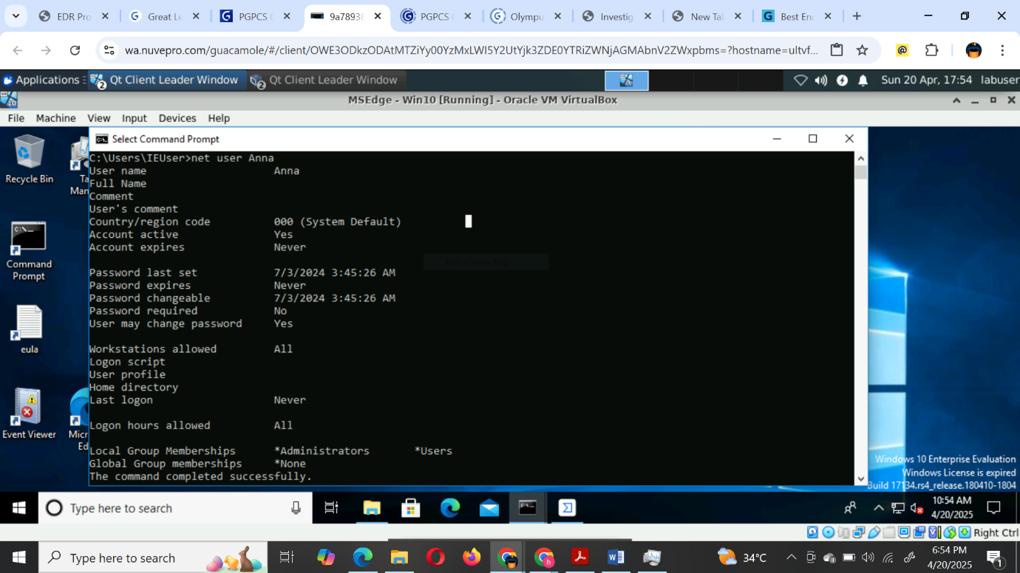

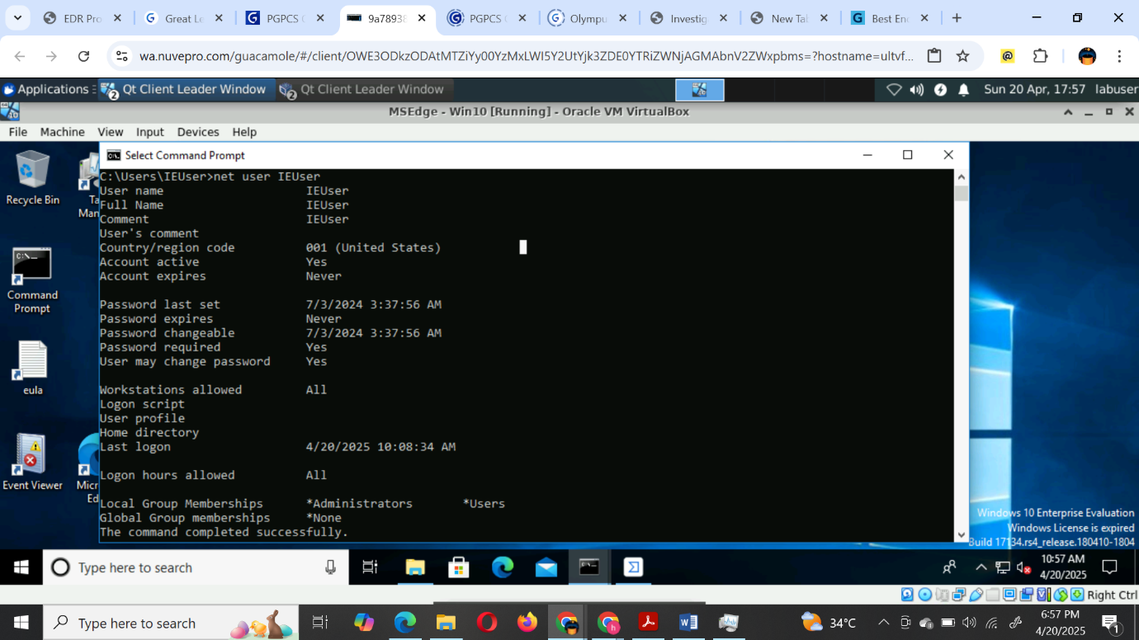
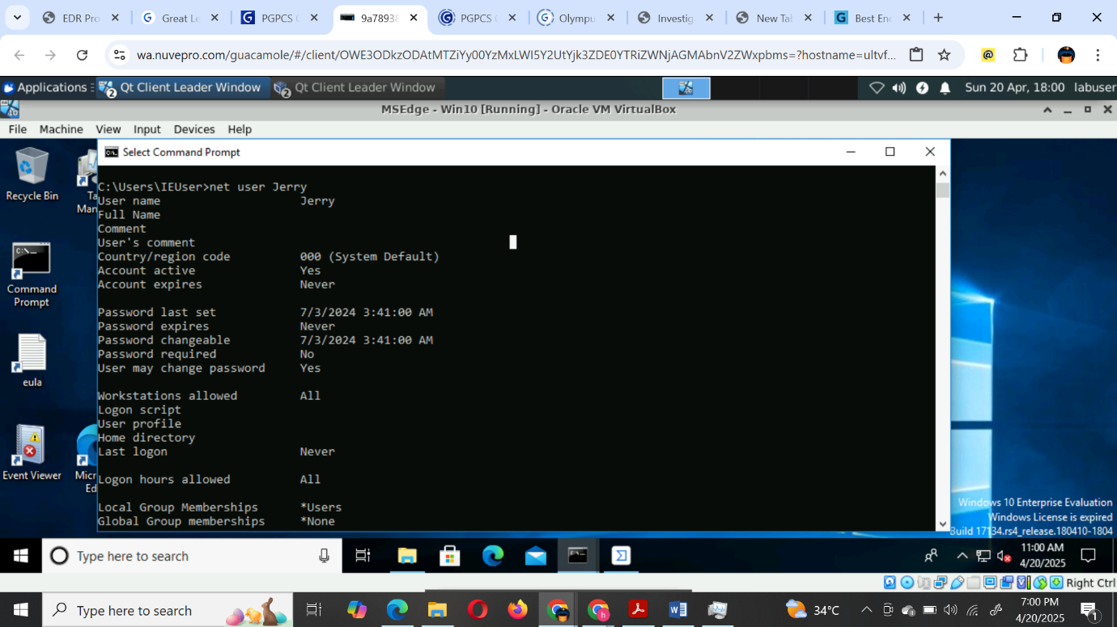

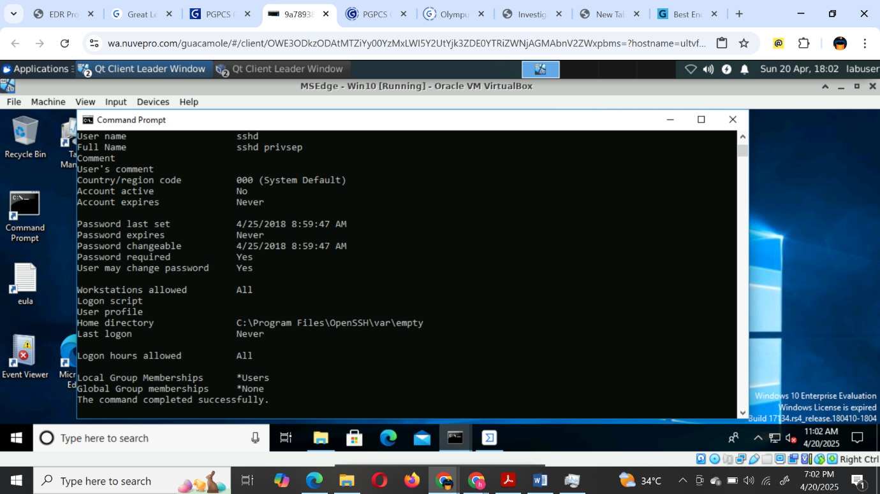

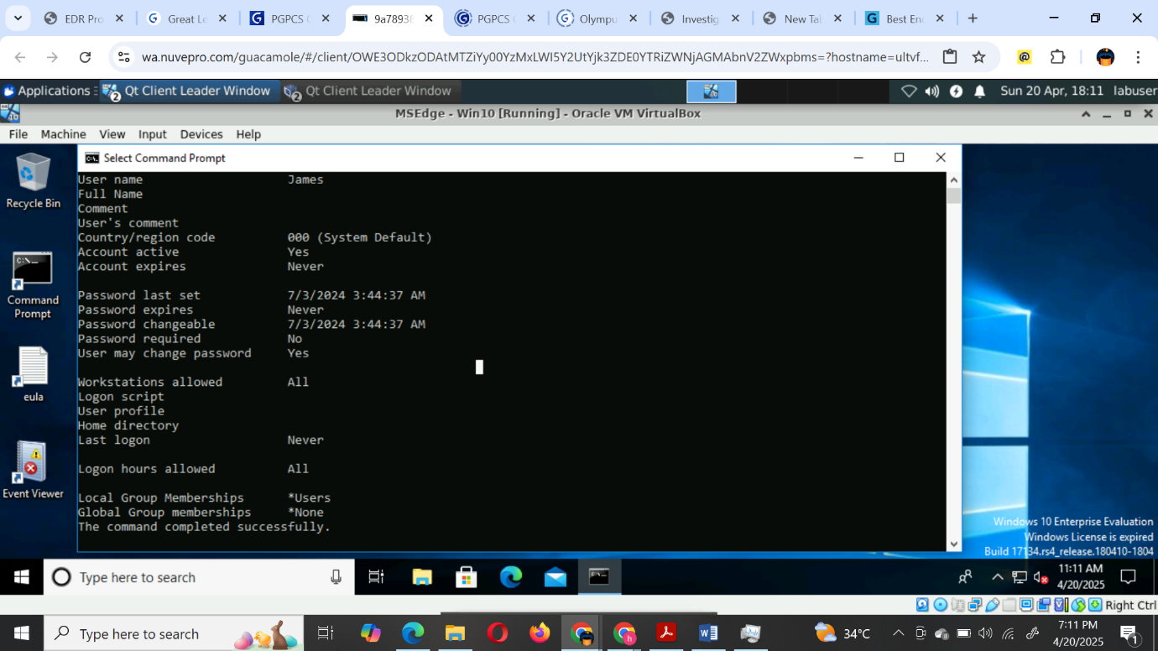
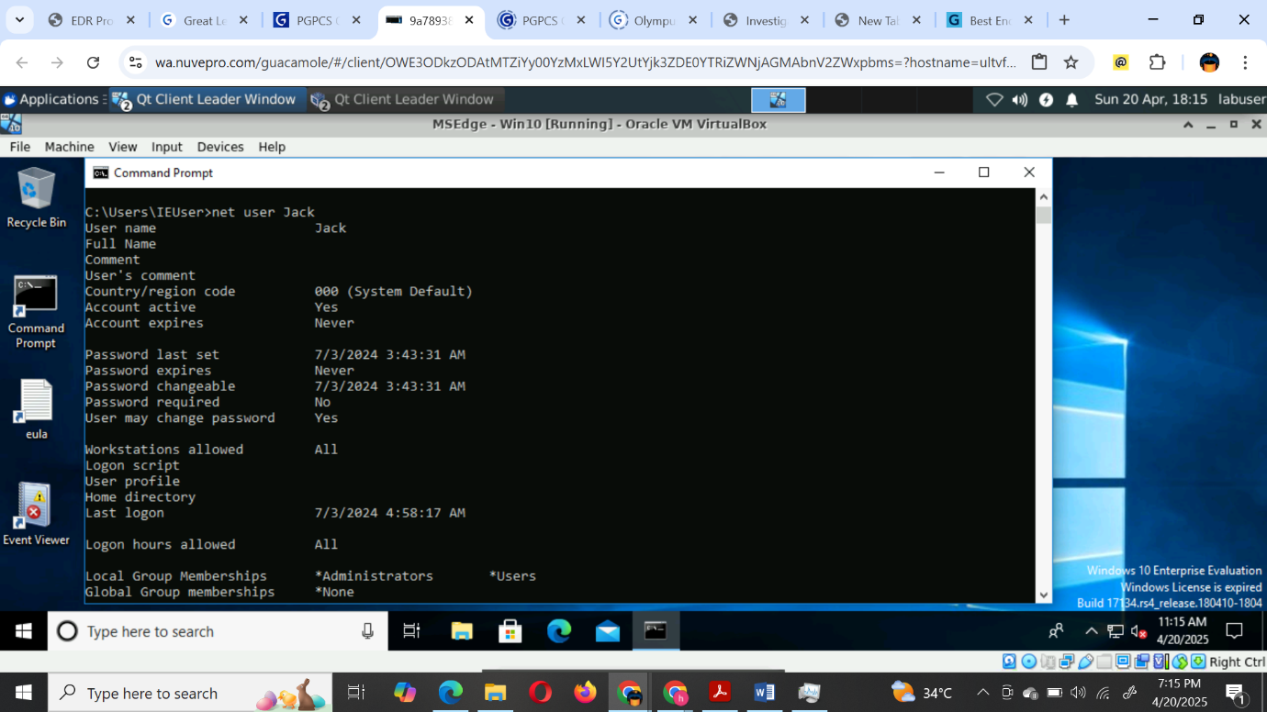
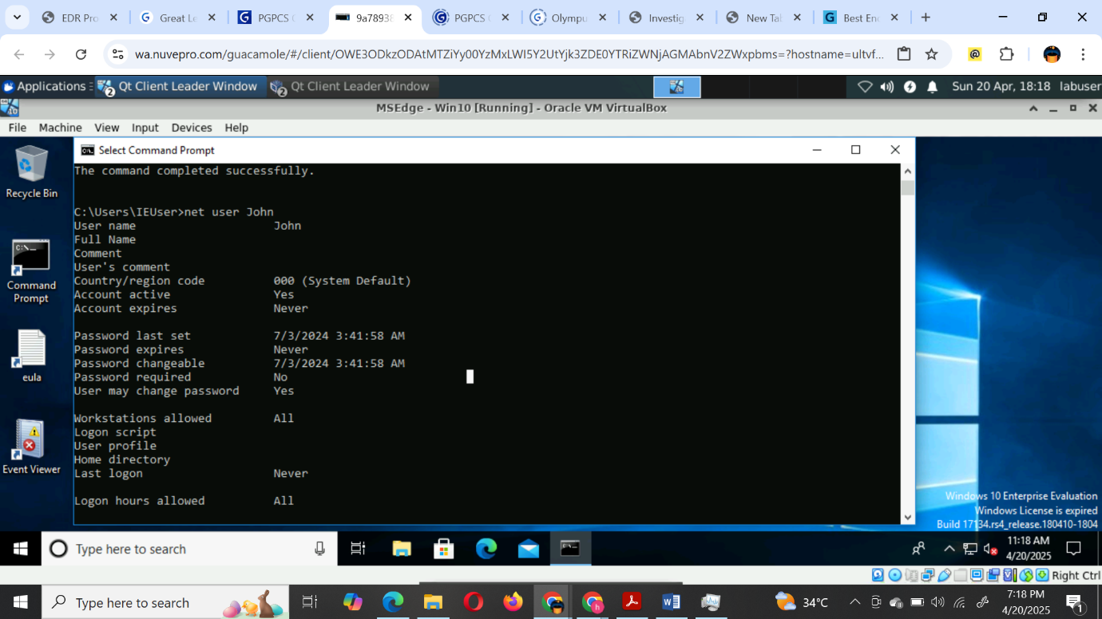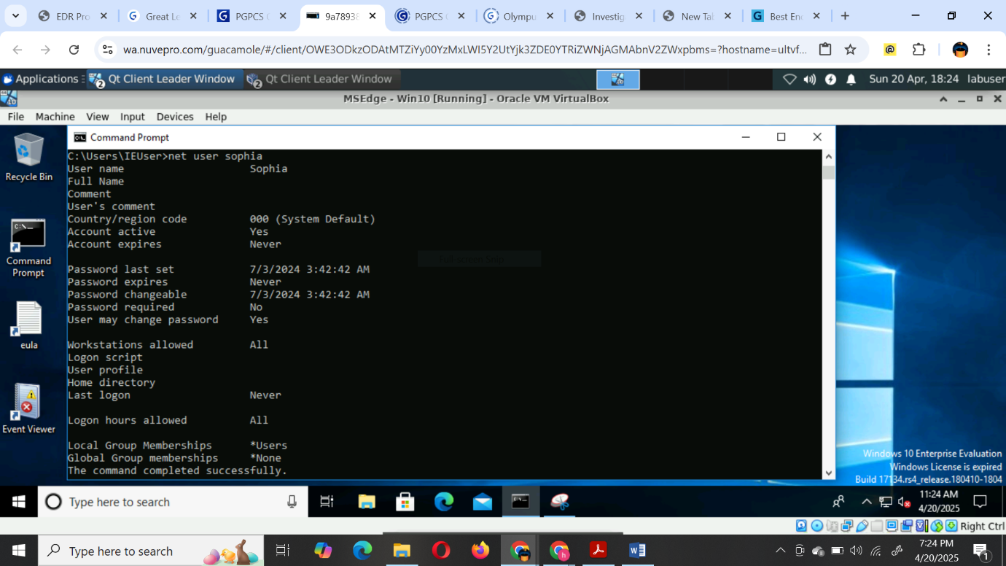

User Name | Last Logon Time | Admin Privilege (Yes/No)
Jerry | Never | NO
Jack | 7/3/2024 4:58:17 Am | YES
John | Never | NO
James | Never | NO

Task 4:
- Complete the following table: (Please provide a screenshot of the details for any one of the failed logon attempts from Windows Event Viewer) (2 Points)
Answer:

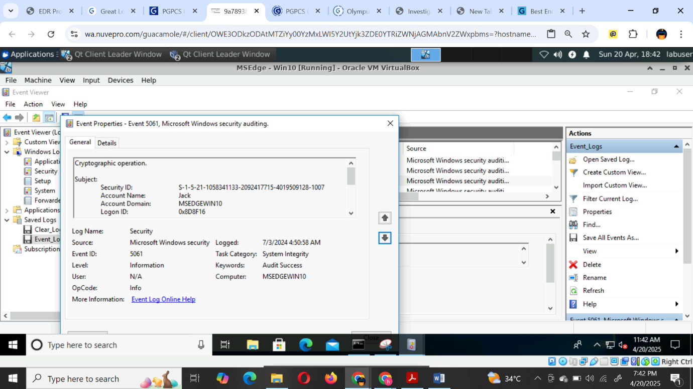

User Name | Number of failed logons | Timestamp of the failed logons
Jerry
Jack | 5 | 7/3/2024 4:50.58 AM
John
James

Task 5:
- Complete the following table: (Please provide the screenshot of the Event Properties analysed on the Windows Event Viewer) (2 Points)
Answer:

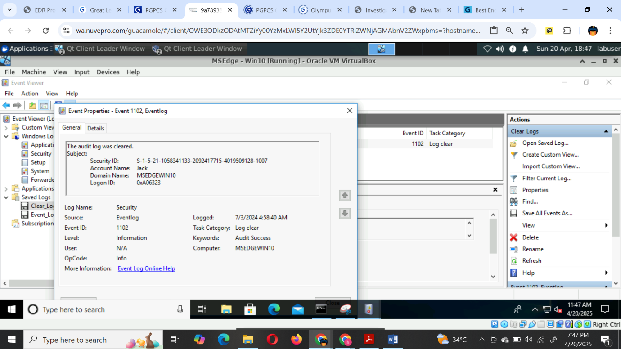

Name of the User who cleared the logs | Time at which the log was cleared
JACK | 7/3/2024 4:58:40

Task 6:
[Hint: Use the results you have determined for the questions in Tasks 1, 2, 3, 4 and 5]
- Based on the information you found by performing the investigation, prepare a summary report describing all the malicious activities on the compromised machine. [Word Limit: 150 words] (2 Points)
Answer:
Based on the investigation, Jack's user account exhibited suspicious activity, including five failed login attempts on July 3, 2024, despite his scheduled work hours being from 10 AM to 7 PM. Notably, these attempts occurred at 4:58 AM, indicating potential unauthorized access. Furthermore, Jack, a Service Desk Analyst, should not have administrative privileges, yet the account was granted elevated access, suggesting a significant security breach.

The attacker successfully logged into Jack’s account at 4:58:17 AM. Shortly after, at 4:58:40 AM, the attacker cleared the audit logs to obfuscate their actions and avoid detection. Additional analysis revealed that the file sshd.exe was utilized for SSH communication from the compromised machine. This highlights the need for immediate remediation measures and a review of user privilege assignments to prevent similar incidents in the future.

- For the next phase of investigation, what all things would you check next? (2 Points)
Answer:
1 - What specific time did the attacker successfully log in using Jack's credentials?
2 - What methods or vulnerabilities did the attacker exploit to gain escalated privileges?
3 - At what exact time did the attacker achieve escalated privileges?
4 - Did the attacker execute or install any additional malicious files or software during the breach?
5 - Were there any unusual patterns of activity leading up to the successful login?
6 - What other accounts or systems did the attacker access after gaining elevated privileges?
7 - Is there evidence of lateral movement within the network following the initial compromise?

